General

Introduction and Intended Use (Informative)
This standard defines a multi-pole interface for vehicles with limited installation volume for electronic components. It is suitable for N and TT gauges, as well as smaller vehicle installations in HO gauge.

References
This standard should be interpreted in the context of the following NMRA Standards, Technical Notes, and Technical Information.

Normative
- S-9.1.1 DCC Interfaces, which specifies general DCC interface requirements
- S-9.2.3 DCC Service Mode, which specifies service mode programming requirements

Informative
- TN-9.1.1 DCC Interfaces, which provides commentary on general DCC interface requirements
- TN-9.1.1.5 Next18 and Next18-S Decoder Interface, which provides commentary on the Next18 and Next18-S decoder interface
- TI-9.1.1 Sources for Connectors for DCC, which provides a list of manufacturer part numbers for DCC interface connectors
- TI-9.2.3 Serial User Standard Interface for DCC, which provides information on SUSI
- RCN-118 Decoder Interfaces Next18/Next18-S, with which this standard is intended to be in harmony
- NEM 662 Electrical Interface Next 18, with which this standard is intended to be in harmony

Terms
Term | Definition
Vehicle | Mobile model railroad device. This includes locomotives and other rolling stock.
Decoder | DCC receiver for controlling vehicle animation.
System Board | Electronic circuit board that is considered part of the vehicle which a decoder is intended to be plugged into.
Train Bus | Serial User Standard Interface (SUSI)

Requirements
To meet this standard all mechanical and electrical values mentioned must be met and respected, unless otherwise noted. It is not necessary to implement all connections of the interface. The connections belonging to unimplemented features must remain unconnected. This applies to vehicles as well as for other devices that use this interface.

Mechanical Properties
The interface consists of an encapsulated 18-pin socket (Figure 1) on the system board of vehicle and the encapsulated 18-pin header (Figure 2) on the decoder.
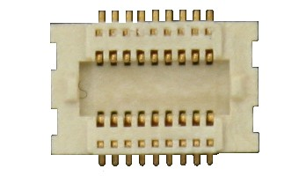Figure 1 18-pin socket
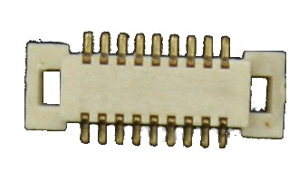Figure 2 18-pin plug
The electrical connections are arranged symmetrically to prevent damages if installed in a rotated orientation. However, the vehicle shall reserve space such that intended installation orientation is obvious.
The interface is divided into two installation volumes:
- Next18: Electronic components (locomotive and/or function decoder) without sound
- Next18-S: electronic components (locomotive and/or function decoder) with sound
Table 1
Dimension | Description | Next18  (without sound) | Next18-S  (with sound)
a | Decoder length | 15.0 mm | 25.0 mm
b | Decoder width | 9.5 mm | 9.5 mm
c | Decoder height | 2.9 mm | 4.1 mm
d | Distance from edge of decoder to center of connector | 2.5 mm | 2.5 mm
e | Distance from decoder edge to assembly with max Height of 0.5 mm | 5.4 mm | 5.4 mm
f | Distance from decoder edge to assembly with max height of 1.5 mm | 5.9 mm | 5.9 mm

A decoder with the dimensions permitted for the Next18-S must provide a functional speaker connection.
The installation space in vehicle must be designed so that no components of the decoder touch bare metal parts or conductive traces. The installation space, dimensions according to Table 1, should be dimensioned so that the decoder fits into the installation space.
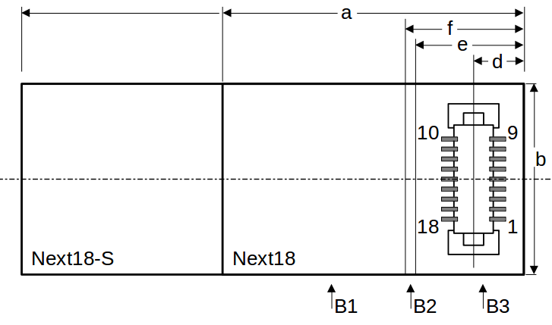Figure 3 View from component side of connector
- max 1.5 mm permitted
- max 0.5 mm permitted
- no assembly components allowed in this area

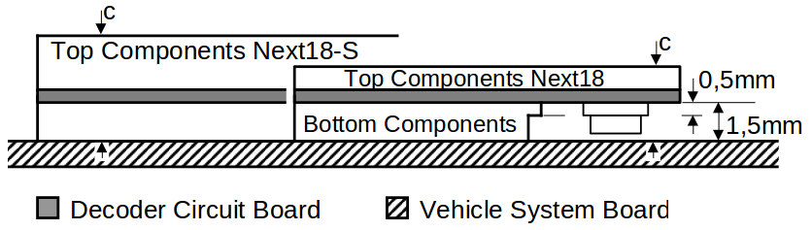Figure 4 Decoder side view
The maximum assembly height of components on the bottom of the decoder is 1.5 mm. The placement height on the top of the decoder is calculated from the maximum decoder height minus the assembly height for bottom components (1.5 mm) and the thickness of the circuit board used.

Plug Specification
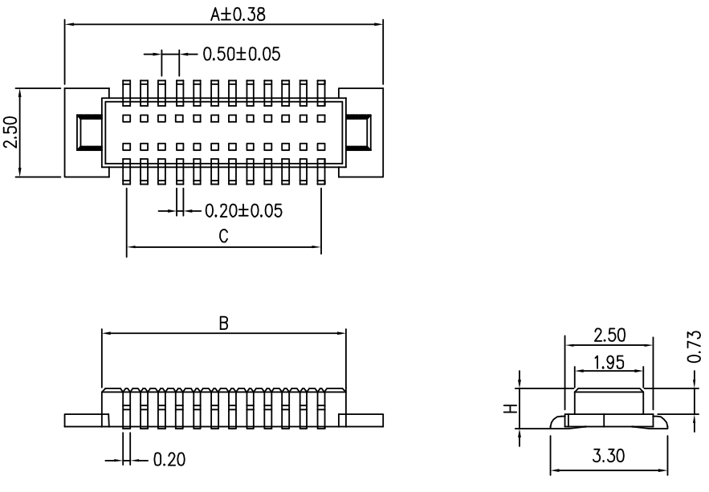
Material
- Housing:
High temperature plastic (94-V0)
- Contact:
Copper alloy (t = 0.2 mm) Gold over nickel plating
Specification
- Current carrying capacity 0.5A max
- Insulation resistance:
1000 MΩ at 500V DC
- Dielectric strength:
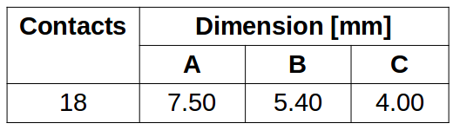
150 Vrms AC at 0.5 mA for 1 minute
- Contact resistance: 50 mΩ max
- Operating temperature:
-40C to +105C
- Maximum processing temperature:
230C for 30 – 60 seconds

Socket Specifications
Material
- Housing:
High temperature plastic (94-V0)
- Contact:
Copper alloy (t = 0.2 mm) Gold over nickel plating
Specification
- Current carrying capacity 0.5A max
- Insulation resistance:
1000 MΩ at 500V DC
- Dielectric strength:
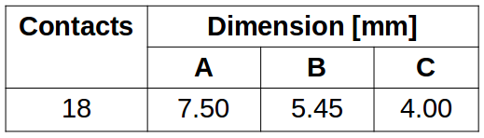
150 Vrms AC at 0.5 mA for 1 minute
- Contact resistance: 50 mΩ max
- Operating temperature:
-40C to +105C
- Maximum processing temperature:
230C for 30 – 60 seconds

Electrical Properties
The contact rating is 0.5A. The track connections as well as V+ and GND (decoder plus and after rectifier) are each made with two contacts making their effective load capacity 1.0 A. The system board of the vehicle, as well as the decoder, must be designed so that if they make different use of the LS_A/AUX5 and LS_B/AUX6, no damage to the vehicle system board or decoder will occur.

Next18 Pin Assignment
Pin | Name | Description | Group
1 | Track Right | Track connection right rail | 1
2 | Motor + | Motor connection 1 plus / forward | 2
3 | AUX1 | Output 1 | 3
4 | AUX3/TBCLK | Output 3 | 4
5 | GND | Decoder ground, after rectifier
6 | V+ | Decoder plus, after rectifier
7 | AUX6 | Output 6 | 4
8 | F0F | Forward Headlight | 3
9 | Track Left | Track connection left rail | 1
10 | Track Left | Track connection left rail | 1
11 | Motor - | Motor connection 2 minus / reverse | 2
12 | AUX2 | Output 2 | 3
13 | AUX4/TBDAT | Output 4 | 4
14 | GND | Decoder ground, after rectifier
15 | V+ | Decoder plus, after rectifier
16 | AUX5 | Output 5 | 4
17 | F0R | Reverse Headlight | 3
18 | Track Right | Track connection right rail | 1

Next18-S Pin Assignment
Pin | Name | Description | Group
1 | Track Right | Track connection right rail | 1
2 | Motor + | Motor connection 1 plus / forward | 2
3 | AUX1 | Output 1 | 3
4 | AUX3/TBCLK | Output 3 | 4
5 | GND | Decoder ground, after rectifier
6 | V+ | Decoder plus, after rectifier
7 | Speaker B | Speaker connection B | 5
8 | F0F | Forward Headlight | 3
9 | Track Left | Track connection left rail | 1
10 | Track Left | Track connection left rail | 1
11 | Motor - | Motor connection 2 minus / reverse | 2
12 | AUX2 | Output 2 | 3
13 | AUX4/TBDAT | Output 4 | 4
14 | GND | Decoder ground, after rectifier
15 | V+ | Decoder plus, after rectifier
16 | Speaker A | Speaker connection A | 5
17 | F0R | Reverse Headlight | 3
18 | Track Right | Track connection right rail | 1

Descriptions of Signals
- Track Right (pins 1 & 18) and Track Left (pins 9 & 10) are connected to the vehicle weeks for the incoming power supply.
- Motor + (pin 2) is normally connected to the right rail. Motor – (pin 11) is normally connected to the left rail.
- These outputs are open collector/drain switched against ground on the decoder side. The voltage for the load comes from the Track voltage at V+ (pins 6 & 15). In the case where there are taillights connected separate from the headlights, the taillights in the forward direction (cab 1) are connected to AUX1 (pin 3) and the taillights in the reverse direction (cab 2) are connected to AUX2 (pin 12). Maximum load capacity is 100 mA per output.
- Outputs are defined as TTL/LVTTL logic-level according to Table 2. Maximum load 0.5 mA. If Train Bus is supported, the decoder must include a 470 ohm series resistor on AUX3/TBCLK (pin 4) and AUX4/TBDAT (pin 13), and must have a 15K ohm (or greater) pull-up on TBDAT (pin 13) before the 470 ohm series resistor. (AUX5/AUX6 NEXT18 only)
- The impedance of the speaker is determined by the manufacturer of the decoder and must be documented. (NEXT18-S only)
If a voltage V+ is independently generated on the vehicle system board, it must not be connected to V+ (pins 6 & 15) of this interface.
Table 2 TTL/LVTTL voltage levels
 | Decoder Output Voltage Level | System Board Input Voltage Level
Function switched off | <= 0.4V | <= 0.8V
Function switched on | >= 2.4V | >= 2.0V

Use in Function Only Decoders
This interface can be used in vehicles without a motor. Since there is no motor connection in this case, the decoder must have an internal means of generating the required service mode acknowledgment as defined in S-9.2.3.

Use of Interface with SUSI
This interface can also be used as a SUSI interface according to TI-9.2.3. In this case, only four signals may be used
- GND (pins 5 & 14)
- V+ (pins 6 & 15)
- Train Bus Clock (pin 4)
- Train Bus Data (pin 13)
In particular, the track connections are not to be used when wired as a SUSI interface. All other connections can be used for functions of the SUSI module.

Operation Without a Decoder
For the operation of the vehicle without electronic components in the interface, a dummy plug must be used.
Minimal dummy plug Bridge plug with Bridge plug with functions
functions F0F and F0R F0F, F0R, AUX1, and AUX2
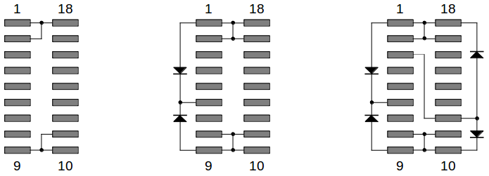Figure 5 Typical dummy plugs
The typical bridge plug connects the following contacts
Track right: Motor +, F0R, (AUX1 if taillight included in forward direction)
Track left: Motor -, F0F, (AUX2 if taillight included in reverse direction)
Depending on the wiring of the function outputs in the vehicle, the vehicle manufacturer may setup a bridge plug specific to the vehicle if other outputs are connected. In the middle picture, outputs F0F and F0R are controlled depending on the direction. Functions AUX1 and AUX2 are always switched on in the picture on the right.

